Ideation Phase
Define the Problem Statements
Date | 19 February 2026
Team ID | LTVIP2026TMIDS41489
Project Name | Intellisql: intelligent sql querying with llms using gemini pro
Maximum Marks | 2 Marks

Customer Problem Statement Template:
Accessing useful insights from databases often demands strong SQL skills, a clear understanding of database schemas, and experience in crafting efficient queries. For many students, business users, analysts, and non-technical professionals, turning everyday questions into correct SQL statements involves repeated trial and error, frequent debugging, and navigating complex table structures. This slows down analysis and creates friction in decision-making. Moreover, accurately capturing user intent in SQL is difficult without technical expertise, which can result in misleading or incomplete outputs. Therefore, there is a clear need for an intelligent solution that can translate natural language queries into precise SQL using large language models such as Gemini Pro, allowing users to retrieve reliable data insights quickly and without deep technical knowledge.
Reference:https://miro.com/templates/customer-problem-statement/ 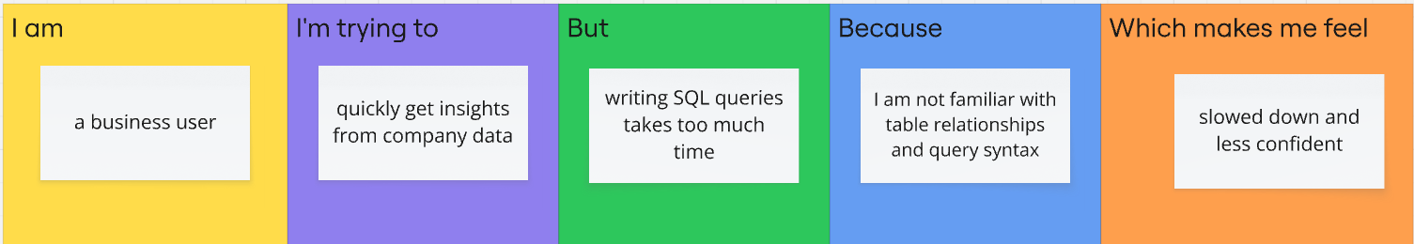
Example:

Problem  Statement (PS) | I am  (Customer) | I’m trying to | But | Because | Which makes me feel
PS-1 | a bussiness user | Quickly get insights from company data | Writing SQL queries takes too much time | I am not familiar with table relationships and query syntax | slowed down and less confident

